Alice Ponder Library Chapter Book Sets
 | Title of Book: | Accelerated Reader Level
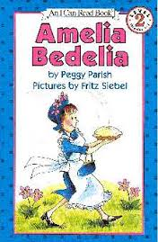 | Amelia Bedelia | 2.5
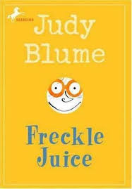 | Freckle Juice | 3.1
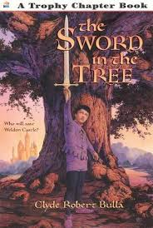 | The Sword and the Tree | 3.2
 | Tornado | 3.2
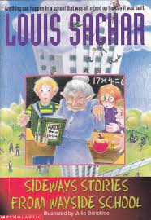 | Sideways Stories from Wayside School | 3.3
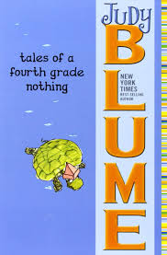 | Tales of a Fourth Grade Nothing | 3.3
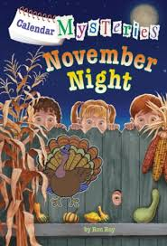 | November Night (A to Z mystery) | 3.3
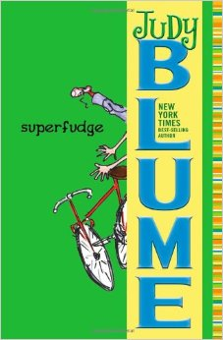 | Superfudge | 3.4
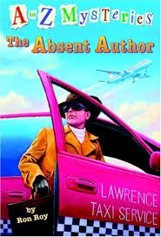 | The Absent Author (Calendar Mysteries Series) | 3.4
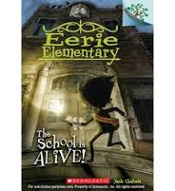 | The School Is Alive (#1 in Eerie Elementary series) | 3.4
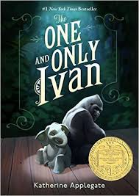 | The One and Only Ivan | 3.6
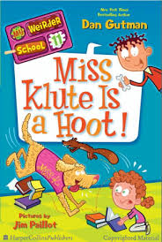 | Miss Klute is a Hoot (Weirder School Series) | 3.7
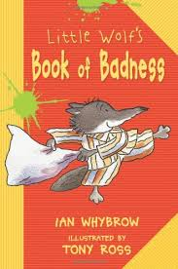 | Little Wolf’s Book of Badness | 3.9
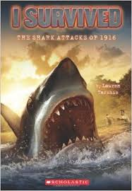 | The Shark Attacks of 1916 (I Survived Series) | 3.9
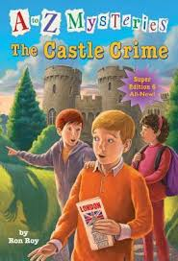 | Castle Crime (A to Z mystery) | 3.9
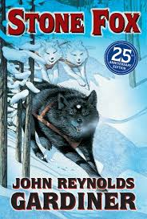 | Stone Fox | 4.0
 | Sheep | 4.0
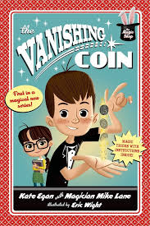 | The Vanishing Coin  (The Magic Shop series) | 4.0
 | Beauty | 4.0
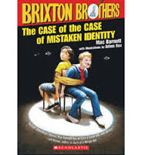 | Brixton Brothers “The Case of the Case of Mistaken Identity” | 4.1
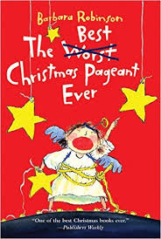 | The Best Christmas Pageant Ever | 4.1
 | Helen Keller: Crusader for the Blind and Deaf | 4.1
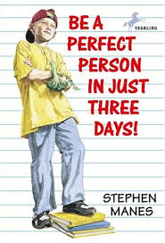 | Be a Perfect Person in Three Days | 4.2
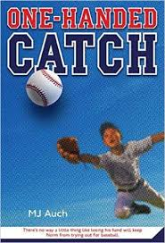 | One Handed Catch | 4.2
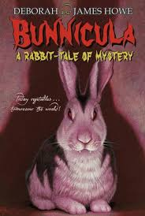 | Bunnicula- A Rabbit Mystery | 4.2
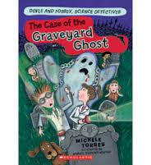 | The Case of the Graveyard Ghost | 4.2
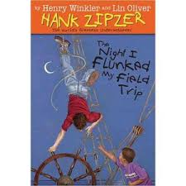 | The Night I Flunked My Field Trip | 4.2
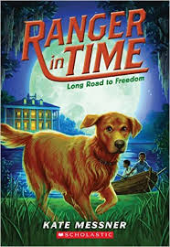 | Long Road to Freedom (Ranger in Time series) | 4.2
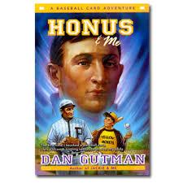 | Honus and Me | 4.3
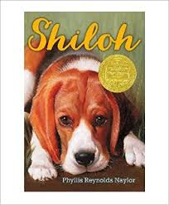 | Shiloh | 4.4
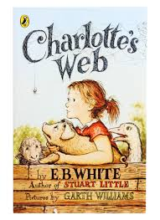 | Charlotte’s Web | 4.4
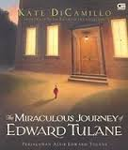 | The Miraculous Journey of Edward Tulane | 4.4
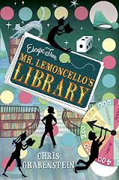 | Escape from Mr. Lemoncello’s Library | 4.5
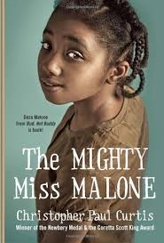 | The Mighty Miss Malone | 4.7
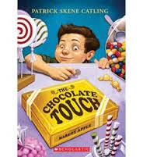 | The Chocolate Touch | 4.7
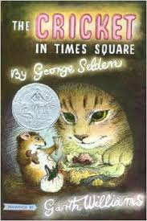 | The Cricket in Times Square | 4.9
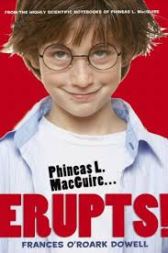 | Phineas L. MacGuire Erupts | 5.0
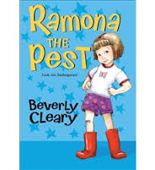 | Ramona the Pest | 5.1
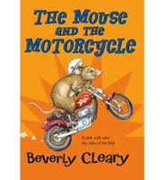 | The Mouse and the Motorcycle | 5.1
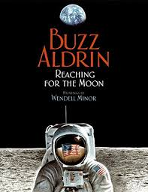 | Reaching for the Moon | 5.1
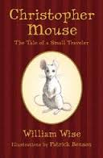 | Christopher Mouse- The Tale of a Small Mouse | 5.3
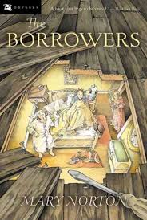 | The Borrowers | 5.3
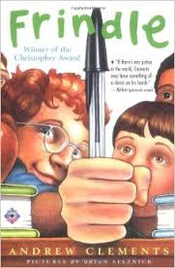 | Frindle | 5.4
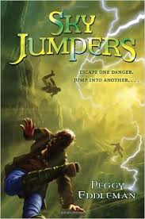 | Sky Jumpers | 5.4
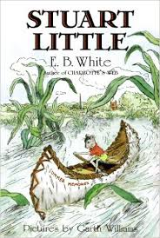 | Stuart Little | 6.0

